### A PROJECT REPORT

**ON**

### PROJECT “CRACKERCODE.COM”

**AT**

### FRONTLINE COREER DEVELOPMENT PVT LTD,

**PUNE BY**

### VISHAL BAPURAO AHER PRN NO. :- 2019015201013924

**UNDER THE GUIDANCE OF PROF.ARUNIMA PUSDEKAR SUBMITTED TO DR. B.A.M.U.**

### IN PARTIAL FULFILLMENT OF THE REQUIREMENT FOR AWARD OF THE DEGREE OF MASTER IN BUSINESS ADMINISTRATION (MBA)



**SHREEYASH INSTITUTE OF MANAGEMENT, AURANGABAD AURANGABAD-431001.**

### 2021-2022

**INPLANT TRAINING PROJECT (MANB 551)**

ON

## “BHAGIRATH FERTILIZER PVT. LTD.”

In Partial Fulfillment of Requirements for the Award of Degree of

## MASTER OF BUSINESS ADMINISTRATION (MBA)

**of Dr. Babasaheb Ambedkar Marathwada University, Aurangabad**

Submitted by

**Shubham Narayan Jadhav**

Roll No.: M122032

MBA [III Sem] Specialization: Marketing

Under the Guidance of

### Prof. Kalyani Mane



**SHREEYASH PRATISHTHAN’S**

**Shreeyash College of Engineering & Technology (SYCET) Department of MBA**

### Aurangabad-431010

### Batch: 2020-22

**Academic Session: October 2021 - April 2022**

Shreeyash Institute of Management Aurangabad Aurangabad-431001.

Institution Approval Letter Summer Internship Program

Mr Vishal Bapurao Aher of batch 2020-2022 is granted permission by the institute to do

the Summer Internship Project title “Stress Management” at Frontline Career Develpment Pvt Ltd,Pune during 20/04/2022 to 20/05/2022.

Prof.Arunima Pusdekar Dr. Anil Palve

Project Guide H.O.D.

**Certificate**

This is to certify that the Project Report titled “**FRONTLINE CAREER DEVELOPMENT PVT LTD PUNE**”which is being submitted herewith for the award of **Master of Business Administration**, Pune is the result of the original research work completed by **MR. AHER VISHAL BAPURAO** under my supervision and guidance and to the best of my knowledge and belief the work embodied in this Project Report has not formed earlierthe basis for the award of any degree or similar title of this or any other University or examining body.

Prof. Arunimma Pusdekar Dr. Anil Palve

Project Guide Name H.O.D.

Place:Aurangabad Date:25 May 2021

**Acknowledgement**

I take the opportunity to express my gratitude towards the valuable people who have contributed towards the successful completion of the project.

First and foremost I would like to thank C.E.O for giving an opportunity to work as a summer trainee in Frontline Career Development Pvt Ltd, Pune.

I would like to thank our HR generalist for her their valuable support during the entire course of project and helping me by sharing valuable information.

I would like to extend my hearty appreciation and thanks to Prof. Arunimma Pusdekar for guiding me incompletion of this project report.

**Declaration**

I, the undersigned, hereby declare that the Project Report titled “**FRONTLINE CAREER DEVELOPMENT PVT LTD, PUNE ”**written and submitted by me to DR. B.A.M.U., in partial fulfillment of the requirement for the award of **Master of Business Administration** is my original work and the conclusions drawn therein are based on the material collected by myself.

Aher Vishal Bapurao PRN NO. :- 2019015201013924

Place: Aurangabad Name & sign of Research Student

|  |  |
| --- | --- |
| **CONTENTS** |  |
| **DECLARATION** | **2** |
| **ACKNOWLEDGEMENT** | **3** |
| **CERTIFICATE** | **4** |
| **ABSTRACT** | **5** |
| **CONTENTS** | **6** |

1. **INTRODUCTION**

### Organization Profile 8

### Introduction of Project 11

### Problem Specification 12

### Problem Definition 12

### Limitation of Existing System 12

### Objective of Project… 13

### SYSTEM ANALYSIS

### Feasible study… 14

### Introduction 14

### Summary and Constraint… 14

### Types of Feasible Study 15

### Hardware and Software Requirements… 17

### DEVELPOMENT ENVIRONMENT

### Introduction to Oracle Database 18

### Introduction to Java… 23

### Introduction to NetBeans Ide 8.1 27

### SYSTEM DESIGN

### Modular Description 31

### IMPLEMENTATION AND TESTING

### Testing… 33

### Implementation and Screenshots… 37

### CONCLUSION… 44

### BIBLIOGRAPHY… 45

# INTRODUCTION

## ORGANISATION PROFILE:

Frontline Labs Pvt. Ltd. is recognized as a leading IT solution providing organization with a dynamic and fast growing team of diversely talented individuals. Incorporated in 2001, in our aim to provide the best talent, we initially started with Recruitment & Staffing services. We paralleled this by providing knowledge and skill development certification training programs. Frontline Certified Tester (WCT) Program that aims to provide IT companies trained software Testers has reached soaring heights of recognition over the years. Few years later after its inception, Frontline Labs added Software development & testing services to the portfolio.

Having partnered and worked with some of the leading names across Education, IT, ITES, Banking, Insurance, Aviation, Retail, Healthcare, Hospitality, Media, Manufacturing and FMCG sectors, Frontline Labs has explored business opportunities in software solutions with the Government, Corporate and Institutes.

With over a decade of experience we create and deliver high-impact solutions, enabling our clients to achieve their business goals and enhance their competitiveness. In our pursuit of excellence, Frontline's Research & Development team consistently innovates to provide up-to-date solutions keeping in pace with changing times. Our mission is for businesses to leverage the internet and mobility to work smarter and grow faster. We work as your outsourcing and consulting partner. Our business verticals are:

### [Recruitment & Staffing](http://www.webteklabs.com/recruitment-staffing.html)

* [**Software Development and Testing Services**](http://www.webteklabs.com/software-development-testing.html)

### [Digital Marketing](http://www.webteklabs.com/digital-marketing.html)

* [**Enterprise Mobility**](http://www.webteklabs.com/enterprise-mobility.html)

### [Certifications & Trainings for Career Management](http://www.webteklabs.com/industrial-training.html)

* [**Software solutions**](http://www.webteklabs.com/software-solutions.html)

**FRONTLINE TEAM** has expertise ranging from design to development, training to placements and solutions to implementaion. We combine this knowledge with proactive thinking and strategic planning to approach new challenges with your overall business objectives in mind. Frontline Lab's management team brings together a wealth of experience in both technological and organizational development that is critical in helping our customers achieve their goals.

# ACTIVITIES

FRONTLINE LABS offers out of the box solutions customized for various segments. Our expertise lies in designing, realizing and deploying customized solutions that integrate multi-vendor Commercial Off The Shelf Solutions, custom device design including software and hardware design.

The system engineering process involves:

* Identifying products and accessories
* Design procure and realize software sub-systems
* Developing system software
* Module integration
* FRONTLINE LABS helps customers and developers save valuable time as itcould be a single source of hardware and software solutions. We provideexpert design support and development services.
* Design Realization

FRONTLINE LABS offers product realization services from idea-to-solution, concept- to deployment covering various aspects of conceptualization, architecture, device design, planning implementation, development, application development, porting and enhancement.

# INTRODUCTION OF PROJECT

## INTRODUCTION

This system is basically concerned with making the students enable to take to the quiz at their own convenience. The need of this system arose because there exist some problems faced by the manual examination systems that are delay in result processing , filing poses a problem , filtering of records is not easy , the chance of loss of records is high and also record searching is difficult. These problems can be easily overcome by Codecrackers.com. Maintenance of the results and results is also very difficult and takes a lot of time and effort in case of manual examinations. Students can choose the subject of their own choice and take the quiz which willefficiently display result at the end of it , enabling student to get to know of his/her performance. This system will be very fast and result processing will be fast and accurate. By computerizing the system, we will be able to overcome many of its limitations and will be able to make it more efficient. The handling of data and records for such a vast system is a very complex task if done manually but it can be made much easier if the system is computerized.

This project has 2 parts:

1. User Database Section.
2. User Result Generation After Quiz.

This project include:

1. Login options for the student.
2. Saving details of the student in the database.
3. Giving choice to the students to select a subject.
4. A no of MCQ flash in front of students to solve.
5. Result generation at the end according to student’s performance.

# PROBLEM SPECIFICATION:

This problem is assigned to me during my core java training to design an application on “ **Codecrackers.com ”** using **Netbeans 8.1** and **Oracle database.**

# PROBLEM DEFINITION:

A data base is maintained of information regarding student’s details like Name , Roll No. , School who have logged in the system with the intention of taking quiz.

This project works by storing the details of students in the database and then enabling the student to choose the subject of his/her choice on which he/she wants to take quiz and evaluate their performance. Later generation of the result at the end of the quiz based on the performance of the student.

# LIMITATION OF EXISTING SYSTEM:

## Data redundancy:

It means that same data fields appear in many different files and often indifferent formats. In Manual system it poses quite a big problem because the data has to be maintained in large Volumes, but in our system, this problem can be overcome by providing the condition that if The data entered is duplicate, it will not be entered otherwise updating will take place.

# Difficulty in accessing the data:

In manual system, searching information is time consuming but in our system, any information Can be accessed by providing the primary key.

# Unsatisfactory security measures:

In manual system, no security measures were provided but in this system, Password

security Has been provided. The person can access the system byproviding the correct password Otherwise he is denied the access.

## OBJECTIVE OF PROJECT

* 1. The objective of Codecrackers.com is to enable a student to take quiz , evaluate his performance and enhances the scope of improvement .
  2. A test can be compiled with questions from different topics/subjects.
  3. This project also stores the basic details of the students taking the quiz/test.
  4. It provides the students with the choice to choose his subject and he wants to evaluate his performance, making it user friendly.
  5. At the end result is generated based on the performance of the student which is very fast and efficient.
  6. Due to excessive amount of work done in manual testing the evaluators tend to do mistakes. Here , the chance of mistake is minimum.
  7. The overall method is very easy and based on few steps. No huge amount of knowledge is needed to complete the task.

## FEASIBILITY STUDY

An initial investigation in a proposal that determines whether an alternative system is feasible. A proposal summarizing the thinking of the analyst is presented to the user for review. When approved, the proposal initiates feasibility study that describes and evaluates candidate systems and provides for the selection of best system that meets system performance requirements.

To do a feasibility study, we need to consider the economic, technical factors in system development. First a project team is formed. The team develops system flowcharts that identify the characteristics of candidate systems, evaluate the performance of each system, weigh system performance and cost data and select the best candidate system for the job. The study culminates in a final report to the management.

# INTRODUCTION:

1. Describe and identify characteristics of candidate systems.
2. Determine and evaluate performance and cost effectiveness of each candidate system.
3. Weigh system performance and cost data.
4. Select the best candidate system.

# SUMMARY:

1. A feasibility study is conducted to select the best system that meetsperformance requirements. This entails an identification description, an evaluation of candidate systems, and the selection of the best system for the job.
2. A statement of constraints, the identification of specific system objectives and a description of outputs define a system’s required performance. The analyst is then ready to evaluate the feasibility of candidate systems to produce these outputs.
3. Three key considerations are involved in feasibility analysis: economic, technical and behavioural.
4. There are few steps in feasibility study :
   1. **STATEMENT OF CONSTRAINTS: -** Constraints are factors that limit the solution of a problem. Some constraints are identified during the initial investigation

# IDENTIFICATION OF SPECIFIC SYSTEM OBJECTIVES:

**-** Once the constraints are spelled out, the analyst proceeds to identify the system’s specific performance objectives. They are derived from the general objectives specified in the project directive at the end of theinitial investigation. The steps are to state the system’s benefits and then translate them into measurable objectives.

* 1. **DESCRIPTION OF OUTPUTS: -** A final step in system performance definition is describing the output required by the user. An actual sketch of the format and contents of the reports as well as a specification of the media used, their frequency, size and numbers ofcopies required are prepared at this point

# TYPES OF FEASIBLE STUDY :-

* + 1. **Legal Feasibility**: - Determines whether the proposed system conflicts with legal requirements, e.g. a data processing system must comply with the local Data Protection Acts.
    2. **Operational Feasibility: -**Operational feasibility is a measure of how well a proposed system solves the problems, and takes advantage of the opportunities identified during scope definition and how it satisfies the requirements identified in the requirements analysis phase of system development.

The operational feasibility assessment focuses on the degree to which the proposed development projects fits in with the existing business environment and objectives with regard to development schedule, delivery date, corporate culture, and existing business processes.

To ensure success, desired operational outcomes must be imparted during design and development. These include such design- dependent parameters such as reliability, maintainability, supportability, usability, predictability, disposability, sustainability,

behaviors are to be realized. A system design and development requires appropriate and timely application of engineering and management efforts to meet the previously mentioned parameters. A system may serve its intended purpose most effectively when its technical and operating characteristics are engineered into the design. Therefore operational feasibility is a critical aspect of systems engineering that needs to be an integral part of the early design phases

* + 1. **Economic Feasibility: -**The purpose of the economic feasibility assessment is to determine the positive economic benefits to the organization that the proposed system will provide. It includes quantification and identification of all thebenefits expected. This assessment typically involves a cost/ benefits analysis.
    2. **Technical Feasibility: -**The technical feasibility assessment is focused on gaining an understanding of the present technical resources of the organization and their applicability to the expected needs of the proposed system. It is an evaluation of thehardware and software and how it meets the need of the proposed system.

# HARDWARE AND SOFTWARE REQUIREMENTS

## HARDWARE REQUIREMENT:-

* PROCESSOR : Pentium IV processor or Greater
* RAM : 128 Mega Byte (MB) or Greater
* HARDDISK : 1.2 Giga Byte (GB) or Greater
* Keyboard & Mouse
* MONITOR : Colour (For Best Result)
* Printer

# SOFTWARE REQUIREMENTS:-

* Operating System : Windows 2000/ XP /7/8
* Front-End : Netbeans ide 8.1
* Back-end : oracle database

# DEVELOPMENT ENVIRONMENT

## INTRODUCTION TO ORACLE :-

An Oracle **database** is a collection of data treated as a unit. The purpose of a database is to store and retrieve related information. A database server is the key to solving the problems of information management. In general, a [**server**](https://docs.oracle.com/cd/B19306_01/server.102/b14220/glossary.htm#i432724) reliably manages a large amount of data in a multiuser environment so that many users can concurrently access the same data.

All this is accomplished while delivering high performance. A database server also prevents unauthorized access and provides efficient solutionsfor failure recovery.

Oracle Database is the first database designed for enterprise grid computing, the most flexible and cost effective way to manage information and applications. Enterprise grid computing creates large pools of industry- standard, modular storage and servers. With this architecture, each new system can be rapidly provisioned from the pool of components. There is no need for peak workloads, because capacity can be easily added or reallocated from the resource pools as needed.

The database has **logical structures** and **physical structures**. Because the physical and logical structures are separate, the physical storage of data can be managed without affecting the access to logical storage structures.

## ORACLE DATABSE OBJECTS:-

A**schema**is a collection of logical structures of data, or schema objects. Aschema is owned by a database user and has the same name as that user.Each user owns a single schema.

Schema objects can be created and manipulated with SQL and include the following types of objects:

* clusters
* Database links
  + Database triggers
  + Dimensions
  + External procedure libraries
  + Indexes and index types
  + Java classes, Java resources, and Java sources
  + Operators
  + Sequences
  + Stored functions, procedures, and packages
  + Synonyms
  + Tables and index-organized tables
  + Views

Other types of objects are also stored in the database and can be created and manipulated with SQL but are not contained in a schema:

* + Contexts
  + Directories
  + Profiles
  + Roles
  + Tablespaces
  + Users

Some of the most common schema objects are defined in the following section.

### Tables: -

Tables are the basic unit of data storage in an Oracle database. Database tables hold all user-accessible data. Each table has [**column**](https://docs.oracle.com/cd/B19306_01/server.102/b14220/glossary.htm#i432240)s and [**row**](https://docs.oracle.com/cd/B19306_01/server.102/b14220/glossary.htm#i432693)s. A table that has an employee database, for example, can have a column called employee number, and each row in that column is an employee's number.

### Indexes:-

**Indexes** are optional structures associated with tables. Indexes can be created to increase the performance of data retrieval. Just as the index in this manual helps you quickly locate specific information, an Oracle index provides an access path to table data.

When processing a request, Oracle can use some or all of the available indexes to locate the requested rows efficiently. Indexes are useful when applications frequently query a table for a range of rows (for example, all employees with a salary greater than 1000 dollars) or a specific row.

Indexes are created on one or more columns of a table. After it is created, an index is automatically maintained and used by Oracle. Changes to table data (such as adding new rows, updating rows, or deleting rows) are automatically incorporated into all relevant indexes with complete transparency to the users.

### Views:-

**Views** are customized presentations of data in one or more tables or other views. A view can also be considered a stored query. Views do not actually contain data. Rather, they derive their data from the tables on which they are based, referred to as the **base tables** of the views.

Like tables, views can be queried, updated, inserted into, and deleted from, with some restrictions. All operations performed on a view actually affect the base tables of the view.

Views provide an additional level of table security by restricting access to a predetermined set of rows and columns of a table. They also hide data complexity and store complex queries.

### Clusters:-

**Clusters** are groups of one or more tables physically stored together because they share common columns and are often used together. Because related rows are physically stored together, disk access time improves.

Like indexes, clusters do not affect application design. Whether a table is part of a cluster is transparent to users and to applications. Data stored in a clustered table is accessed by SQL in the same way as data stored in anon- clustered table.

### Synonyms:

Asynonymis an alias for any table, view, materialized view, sequence, procedureFunction, package, type, Java class schema object, user-defined object type, or another Synonym. Because a synonym is simply an alias, it requires no storage other then Definition in the data dictionary.

### Sequences

Tables usually have a primary key which uniquely identifies a row in a table. A sequence is a unique number generator which can be assigned to the primary keys of the tables.

### Partitions

Partitioning provides tremendous advantages to applications by improving manageability, performance, and availability.

Partitioning allows a table, index or index-organized table to be subdivided into smaller pieces. Each piece of database object is called a partition

. Techniques for partitioning tables:

* Range Partitioning
* List Partitioning
* Hash Partitioning
* Composite Range-Hash Partitioning
* Composite Range-List Partitioning

### Clusters

A cluster is a schema object that contains data from one or more tables, all of which have one or more columns in common.

All the rows from all the tables that share the same cluster key are stored.

After you create a cluster, you add tables to it. A cluster can contain a maximum of 32 tables.

### Stored procedures and packages

A procedure is a PL/SQL block alike the functions of the 3rd generation languages. You just have to compile them so as to use them later.

When a procedure is created, it is compiled and stored in the database in the compiled form.

Parameters can be passed to a procedure.

A procedure call is a PL/SQL statement by itself. A procedure is a PL/SQL block with a declarative section, an executable section and an exception handling section.

Package:

Packages are PL/SQL constructs that allow related objects to be stored together. A package has two separate parts. Each of them is stored separately in the data dictionary.

A package can include procedures, functions, cursors, types, and variables.

### User-defined data types

User defined data types are PL/SQl types that are based on the existing types. Subtypes are used to gives an alternate name to for a type.

### Table spaces

A table space is an area on disk which comprises of one or more disk files. A tablespace can contain many tables, clusters or indexes.

One or more tablespaces together make a database.

Each table has a single area of disk space called a segment set aside for it in the table space.

Each segment has an initial area on disk space set aside for it in the table space called the initial extent.

Once it has been used up, another extent is set aside for it.

### Constraint

Constraints help understand how the tables and columns are related to each other.

The constraint information is accessible under the USER_constraint view. The constraints include the following columns

Owner of constraint Constraint_name Constraint_type Table_name Search_condition

R_Owner - - owner of the foreign key referenced table. R_constraint_name

Delete_rule Status

# INTRODUCTION TO JAVA

* Java is an object oriented programming language originally developed by Sun Microsystems and released in 1995.
* Java was originally developed by James Gosling at Sun Microsystems(which has since merge into Oracle Corporation).
* Java programs are platform independent which means they can be run on any operating system with any type of processor as long as the Java interpreter is available on that system.
* Java code that runs on one platform does not need to be recompiled to run on another platform, it’s called “write once, run anywhere” (WORA).
* Java virtual machine (JVM) executes Java code, but is written in platform specific languages such as C/C++/ASM etc. JVM is not written in Java and hence cannot be platform independent and Java interpreter is actuallya part of JVM.

# USES OF JAVA

Earlier, java was only used to design and program small computing devicesbut later adopted as one of the platform independent programming languageand now according to Sun, 3 billion devices run java. Java is one of the most important programming language in today’s IT industries.

* + JSP – Java is used to create web applications like PHP and ASP, JSP(Java Server Pages) used with normal HTML tags, which helps to create dynamic web pages.
  + Applets – This is another type of Java program that used within a web page to add many new features to a web browser.
  + J2EE – The software Java 2 Enterprise Edition are used by various companies to transfer data based on XML structured documents between one another.
  + JavaBeans – This is something like Visual Basic, a reusable software component that can be easily assemble to create some new and advanced application.
  + Mobile – Besides the above technology, Java is also used in mobile devices, many kind of games and services built in Java. Today, all leading mobile service provider like Nokia, Siemens, Vodafone are using Java technology.

## Types of Java Applications

* + - Web Application Java is used to create server side web applications. Currently, servlet, jsp, struts, jsfetc technologies are used.
    - Standalone Application It is also known as desktop application or window-based application. An application that we need to install on every machine or server such as media player, antivirus etc. AWT and Swing are used in java for creating standalone applications.
    - Enterprise Application An application that is distributed in nature, such as banking applications etc. It has the advantage of high level security, load balancing and clustering. In java, EJB is used for creating enterprise applications.
* Mobile Application Java is used to create application software for mobile devices. Currently Java ME is used for creating applications for small devices, and also Java is programming language for Google Android application development.

## Facts about Java

* Object Oriented – In java everything is an Object. Java can be easily expanded since it is based on the Object model.
* Platform independent – C and C++ are platform dependency languages hence the application programs written in one Operating system cannot run in any other Operating system, but in platform independence language like Java application programs written in one Operating system can able to run on any Operating system.
* Simple – Java is designed to be easy to learn. If you understand the

basic concept of OOP java would be easy to master.

* Secure – With Java’s secure feature it enables to develop virus-free, tamper-free systems. Authentication techniques are based on publickey encryption.
* Architectural neutral – Java compiler generates an architectureneutral object file format which makes the compiled code to be executable on many processors, with the presence Java runtime system. Portable – being architectural neutral and having no implementation dependent aspects of the specification makes Java portable. Compiler and Java is written in ANSI C with a clean portability boundary which is a POSIX subset.
* Robust – Java makes an effort to eliminate error prone situations by emphasizing mainly on compile time error checking and runtime checking.
* Multithreaded – With Java’s multithreaded feature it is possible to write programs that can do many tasks simultaneously. This design feature allows developers to construct smoothly running interactive applications.
* Interpreted – Java byte code is translated on the fly to native machine instructions and is not stored anywhere. The development process is more rapid and analytical since the linking is an incremental and light weight process.
* High Performance – With the use of Just-In-Time compilers Java enables high performance.
* Distributed – Java is designed for the distributed environment of the internet.
* Dynamic – Java is considered to be more dynamic than C or C++ since it is designed to adapt to an evolving environment. Java programs can carry an extensive amount of runtime information that can be used to verify and resolve accesses to objects on runtime.

## Different Editions of Java Technology

* + Java SE – Java SE or Java Standard Edition provides tools and API’s that you can use to create server applications, desktop applications, and even applets. These programs developed using Java SE can be run on almost every popular operating system, including Linux, Macintosh, Solaris, and Windows.
  + JEE – Based on the foundation framework of the standard edition,
  + JME – Java Micro Edition or JME for short is an accumulation of Java APIs that are used for the development of software for devices like mobile phones, PDAs, TV settop boxes, game programming. The platform of micro edition generally consists of an easy user interface, a robust security model and a wide variety of builtin networks for running Java based application.

## Popular Java Editors

To write your java programs you will need a text editor. There are even more sophisticated IDE available in the market. But for now, you can consider one of the following:

* + Notepad – On Windows machine you can use any simple text editor like Notepad (Recommended for this tutorial), TextPad.
  + Netbeans – is a Java IDE that is open source and free which can be downloaded from [www.netbeans.org/index.html](http://www.netbeans.org/index.html)
  + Eclipse – is also a java IDE developed by the eclipse open source community and can be downloaded from <http://www.eclipse.org/>

# INTRODUCTION TO NETBEANS 8.1

**NetBeans**is a[software developmentplatform](https://en.wikipedia.org/wiki/Software_development)written in[Java.](https://en.wikipedia.org/wiki/Java_(programming_language)) The NetBeans Platform allows applications to be developed from a set of modular software componentscalled modules.

Applications based on the NetBeans Platform, including the NetBeans integrated development environment can be extended by[third party developers.](https://en.wikipedia.org/wiki/Third_party_developer)

The NetBeans IDE is primarily intended for development in Java, but also supports other languages, in particular[PHP](https://en.wikipedia.org/wiki/PHP)[,C](https://en.wikipedia.org/wiki/C_(programming_language))/[C++](https://en.wikipedia.org/wiki/C%2B%2B)and[HTML5](https://en.wikipedia.org/wiki/HTML5).

NetBeans is[cross-platform](https://en.wikipedia.org/wiki/Cross-platform)and runs on[Microsoft Windows](https://en.wikipedia.org/wiki/Microsoft_Windows)[,Mac OS X,](https://en.wikipedia.org/wiki/Mac_OS_X) Linux, Solaris other platforms supporting a compatible[JVM](https://en.wikipedia.org/wiki/Java_Virtual_Machine).

# NETBEANS PLATFORM

The NetBeans Platform is a framework for simplifying the development of java swing desktop applications. The NetBeans IDE bundle for Java SE contains what is needed to start developing NetBeans plugins and NetBeans Platform based applications. No additional SDK is required.

Applications can install modules dynamically. Any application can include the Update Center module to allow users of the application to download digitally signed upgrades and new features directly into the running application.

Reinstalling an upgrade or a new release does not force users to download the entire application again.

The platform offers reusable services common to desktop applications, allowing developers to focus on the logic specific to their application. Among the features of the platform are:

* User interface management (e.g. menus and toolbars)
* User settings management
* Storage management (saving and loading any kind of data)
* Window management
* Wizard framework (supports step-by-step dialogs)
* NetBeans Visual Library
* Integrated development tools

# NETBEANS INTEGRATED MODULES

These modules are part of the NetBeans IDE.

# NetBeans Profiler

The NetBeans Profileris a tool for the monitoring of Java applications: It helps developers find memory leaksand optimize speed. Formerly downloaded separately, it is integrated into the core IDE since version 6.0.

The Profileris based on a Sun Laboratories research project that was named JFluid. That research uncovered specific techniques that can be used to lower the overhead of profiling a Java application. One of those techniques is dynamic bytecode

instrumentation, which is particularly useful for profiling large Java applications. Using dynamic bytecode instrumentation and additional algorithms, the NetBeans Profiler is able to obtain runtime information on applications that are too large or complex for other profilers. NetBeans also support Profiling Points that let you profile precise points of execution and measure execution time.

# GUI design tool

Formerly known as project Matisse, the GUI design-tool enables developers to prototype and design Swing GUIs by dragging and positioning GUI components. The GUI builder has built-in support for JSR 295 (Beans Binding technology), but the support for JSR 296 (Swing Application Framework) was removed in 7.1.

# NetBeans JavaScript editor

The NetBeans JavaScript editor provides extended support for JavaScript, Ajax, and CSS.

JavaScript editor features comprise syntax highlighting, refactoring,code completionfor native objects and functions, generation of JavaScript class

skeletons, generation ofAjax callbacks from a template; and automatic browser compatibility checks.

CSS editor features comprise code completion for styles names, quick navigation through the navigator panel, displaying the CSS rule declaration in a List View

and file structure in a Tree View, sorting the outline view by name, type or declaration order (List & Tree), creating rule declarations (Tree only), refactoring a part of a rule name (Tree only).

The NetBeans 7.4 and later uses the new [Nashorn] JavaScript engine developed by Oracle.

# NETBEANS FEATURES

### Best Support for Latest Java Technologies :-

NetBeans IDE is the official IDE for Java 8. With its editors, code analyzers and converters, you can quickly and smoothly upgrade your applications to use new Java 8 language constructs, such as lambdas, functional operations, and method references.

Batch analyzers and converters are provided to search through multiple applications at the same time, matching patterns for conversion to new Java 8 language constructs.

With its constantly improving Java Editor, many rich features and an extensive range of tools, templates and samples, NetBeans IDE sets the standard for developing with cutting edge technologies out of the box.

### Fast & Smart Code Editing :-

An IDE is much more than a text editor. The NetBeans Editor indents lines, matches words and brackets, and highlights source code syntactically and semantically. It lets you easily refactor code, with a range of handy and powerful tools, while it also provides code templates, coding tips, and code generators.

The editor supports many languages from Java, C/C++, XML and HTML, to PHP, Groovy, Javadoc, JavaScript and JSP. Because the editor is extensible, you can plug in support for many other languages.

### Easy & Efficient Project Management :-

Keeping a clear overview of large applications, with thousands of folders and files, and millions of lines of code, is a daunting task. NetBeans IDE provides different views of your data, from multiple project windows to helpful tools for setting up your applications and managing them efficiently, letting you drill down into your data quickly and easily, while giving you versioning tools via Subversion, Mercurial, and Git integration out of the box.

When new developers join your project, they can understand the structure of your application because your code is well-organized

### Rapid User Interface Development

Design GUIs for Java SE, HTML5, Java EE, PHP, C/C++, and Java ME applications quickly and smoothly by using editors and drag-and-drop tools in the IDE.

For Java SE applications, the NetBeans GUI Builder automatically takes care of correct spacing and alignment, while supporting in-place editing, as well. The GUI builder is so easy to use and intuitive that it has been used to prototype GUIs live at customer presentations.

### Write Bug Free Code

The cost of buggy code increases the longer it remains unfixed. NetBeans provides static analysis tools, especially integration with the widely used Find Bugs tool, for identifying and fixing common problems in Java code. In addition, the NetBeans Debugger lets you place breakpoints in your source code, add field watches, step through your code, run into methods, take snapshots and monitor execution as it occurs.

The NetBeans Profiler provides expert assistance for optimizing your application's speed and memory usage, and makes it easier to build reliable and scalable Java SE, JavaFX and Java EE applications. NetBeans IDE includes a visual debugger for Java SE applications, letting you debug user interfaces without looking into source code. Take GUI snapshots of your applications and click on user interface elements to jump back into the related source code.

### Support for Multiple Languages

NetBeans IDE offers superior support for C/C++ and PHP developers, providing comprehensive editors and tools for their related frameworks and technologies. In addition, the IDE has editors and tools for XML, HTML, PHP, Groovy, Javadoc, JavaScript, and JSP.

### Cross Platform Support

NetBeans IDE can be installed on all operating systems that support Java, from Windows to Linux to Mac OS X systems. Write Once, Run Anywhere, is as true for NetBeans IDE as it is for your own applications... because NetBeans IDE itself is written in Java, too

### Rich Set of Community Provided Plugins

The NetBeans community is large and active; many users are developing new plugins all the time because NetBeans IDE is extensible and has well-documented APIs. Are you missing a feature in NetBeans IDE? Create a plugin that fills the gap and participate in making NetBeans even better than it already is!

# SYSTEM DESIGN

## MODULAR DESCRIPTION

1. **LOGIN AND REGISTRATION: -**In this module new student or user requires to enter his all details that’s has been asked to enter in signup form. No field be remain unfilled.

All these details gets stored in the database, creating record for each student also these details can be accessed further.

1. **CHOICE OF SUBJECTS :-** Here the students are new and want to explore their potential. So the choice is given to them in the form of topic/subjects, in which they can take the quiz in which they are comfortable, so as to evaluate their performance and enhance their scope of further improvement

.

1. **CATEGORIES OF SUBJECTS:-** Initially two subjects and topics is provided that are-
   * C++
   * JAVA

Both are the famous programming languages and the students can choose either of these based on their preference. A no. of subjects can be added to this .

1. **MCQ’s OF C++:** A total of 8 MCQ’s will be present in the quiz based on C++ and displayed on screen when the student chooses the C++ as subject.
2. **MCQ’s OF JAVA :** A total of 8 MCQ’s will be present in the quiz based on JAVA and displayed on screen when the student chooses the JAVA as subject.
3. **RESULT GENERATION:** At the end of the quiz i.e. the 8 MCQ’s the result will be generated when the user or student submit his test. The result is generated based on the student’s performance or his inputs. The result will enable the user to access his performance and improve it.

# TESTING AND IMPLEMENTATION

## TESTING:-

Testing is the process of exercising software with the intent of finding errors andultimately correcting them. The following testing techniques have been used to make this project free of errors.

### Content Review

The whole content of the project has been reviewed thoroughly to uncover typographical errors, grammatical error and ambiguous sentences.

### Navigation Errors

Different users were allowed to navigate through the project to uncover thenavigation errors. The views of the user regarding the navigation flexibility and user friendliness were taken into account and implemented in the project.

### Unit Testing

Focuses on individual software units, groups of related units.

* Unit – smallest testable piece of software.
* A unit can be compiled /assembled / linked/loaded; and put under a test harness.
* Unit testing done to show that the unit does not satisfy the application and

/or its implemented software does not match the intended designed structure.

### Integration Testing

Focuses on combining units to evaluate the interaction among them

* Integration is the process of aggregating components to create larger components.
* Integration testing done to show that even though components were individually satisfactory, the combination is incorrect and inconsistent.

### System testing

Focuses on a complete integrated system to evaluate compliance with specified requirements (test characteristics that are only present when entire system is run)

* A system is a big component.
* System testing is aimed at revealing bugs that cannot be attributed to acomponent

as such, to inconsistencies between components or planned interactions between components.

* Concern: issues, behaviors that can only be exposed by testing the entire integrated system (e.g., performance, security, recovery)each form encapsulates (labels, texts, grid etc.). Hence in case of project in V.B. form are the basic units. Each form is tested thoroughly in term of calculation, display etc.

### Regression Testing

Each time a new form is added to the project the whole project is testedthoroughly to rectify any side effects. That might have occurred due to the addition of the new form. Thus regression testing has been performed.

### White-Box testing

White-box testing (also known as clear box testing, glass box testing, transparent box testing and structural testing) tests internal structures or workings of a program, as opposed to the functionality exposed to the end-user. In white-box testing an internal perspective of the system, as well as programming skills, are used to design test cases. The tester chooses inputs to exercise paths through the code and determine the appropriate outputs.

This is analogous to testing nodes in a circuit, e.g. in-circuit testing (ICT).

While white-box testing can be applied at the unit, integration and system levels of the software testing process, it is usually done at the unit level. It can test paths within a unit, paths between units during integration, and between subsystems during a system–level test. Though this method of test design can uncover many errors or problems, it might not detect unimplemented parts of the specification or missing requirements.

Techniques used in white-box testing include:

**API testing (application programming interface**) – testing of the application using public and private APIs

**Code coverage** – creating tests to satisfy some criteria of code coverage (e.g., the test designer can create tests to cause all statements in the program to be executed at least once)

**Fault injection methods** – intentionally introducing faults to gauge the efficacyof testing strategies

Code coverage tools can evaluate the completeness of a test suite that wascreated with any method, including black-box testing. This allows the software team to examine parts of a system that are rarely tested and ensures that the most important function points have been tested. Code coverage as a software metric can be reported as a percentage for:

Function coverage, which reports on functions executed

Statement coverage, which reports on the number of lines executed to complete the test

100% statement coverage ensures that all code paths, or branches (in terms of control flow) are executed at least once. This is helpful in ensuring correctfunctionality, but not sufficient since the same code may process different inputs correctly or incorrectly.

### Black-box testing

Black-box testing treats the software as a "black box", examining functionality without any knowledge of internal implementation. The tester is only aware of what the software is supposed to do, not how it does it. Black-box testingmethods include: equivalence partitioning, boundary value analysis, all-pairs testing, state transition tables, decision table testing, fuzz testing, model-basedtesting, use case testing, exploratory testing and specification-based testing.

Specification-based testing aims to test the functionality of software according to the applicable requirements. This level of testing usually requires thorough test cases to be provided to the tester, who then can simply verify that for a given input, the output value (or behaviour), either "is" or "is not" the same as the expected value specified in the test case. Test cases are built around specifications and requirements, i.e., what the application is supposed to do. It uses external descriptions of the software, including specifications, requirements, and designs to derive test cases. These tests can be functional or non-functional, though usually functional.

Specification-based testing may be necessary to assure correct functionality, but it is insufficient to guard against complex or high-risk situations.

One advantage of the black box technique is that no programming knowledge is required. Whatever biases the programmers may have had, the tester likely has a different set and may emphasize different areas of functionality. On the other hand, black-box testing has been said to be "like a walk in a dark labyrinth without a flashlight." Because they do not examine the source code, there are situations when a tester writes many test cases to check something that could have been tested by only one test case, or leaves some parts of the program untested.

This method of test can be applied to all levels of software testing: unit, integration, system and acceptance. It typically comprises most if not all testingat higher levels, but can also dominate unit testing as well.

### Alpha Testing

Alpha testing is simulated or actual operational testing by potential users/customers or an independent test team at the developers' site. Alpha testing is often employed for off-the-shelf software as a form of internal acceptance testing, before the software goes to beta testing.

### Beta Testing

Beta testing comes after alpha testing and can be considered a form of external user acceptance testing. Versions of the software, known as beta versions, are released to a limited audience outside of the programming team. The software is released to groups of people so that further testing can ensure the product hasfew faults or bugs. Sometimes, beta versions are made available to the open public to increase the feedback field to a maximal number of future users.

# IMPLEMENTATION:-

**SCREENSHOTS**

# REGISTRATION PAGE :-

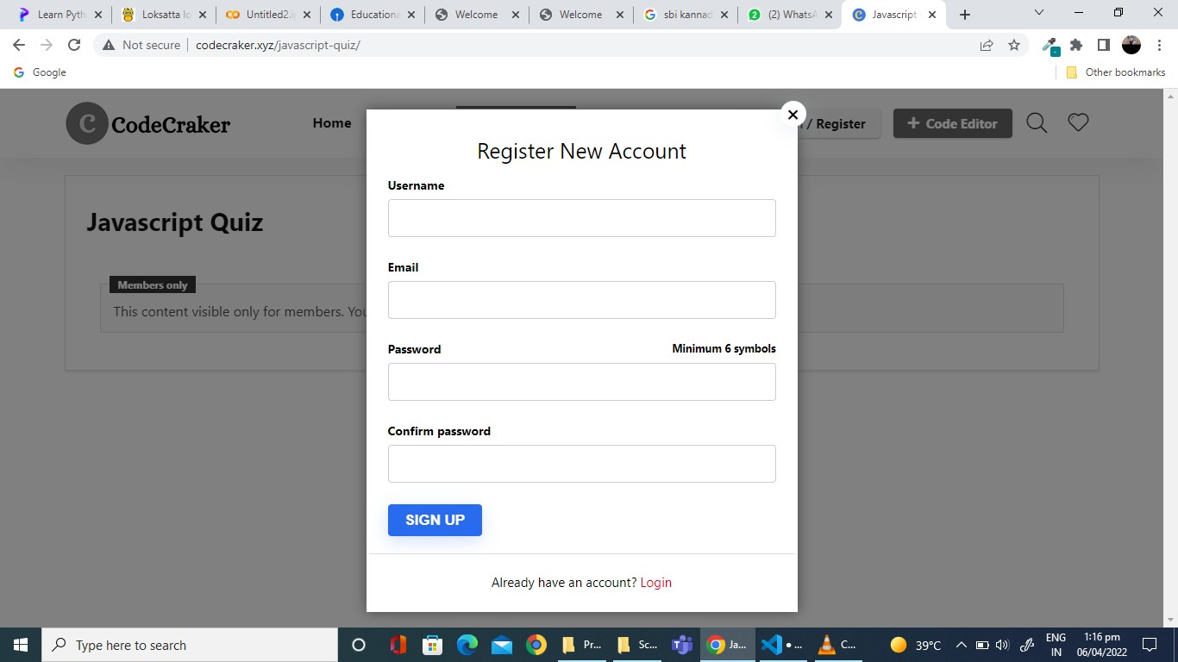

1. **CHOICE OF TOPIC :-**

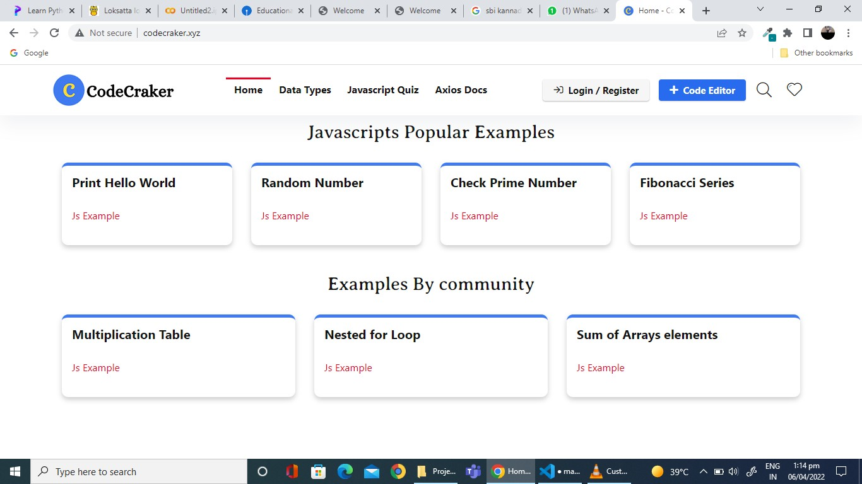

# MCQ’S ON FIRST TOPIC :-

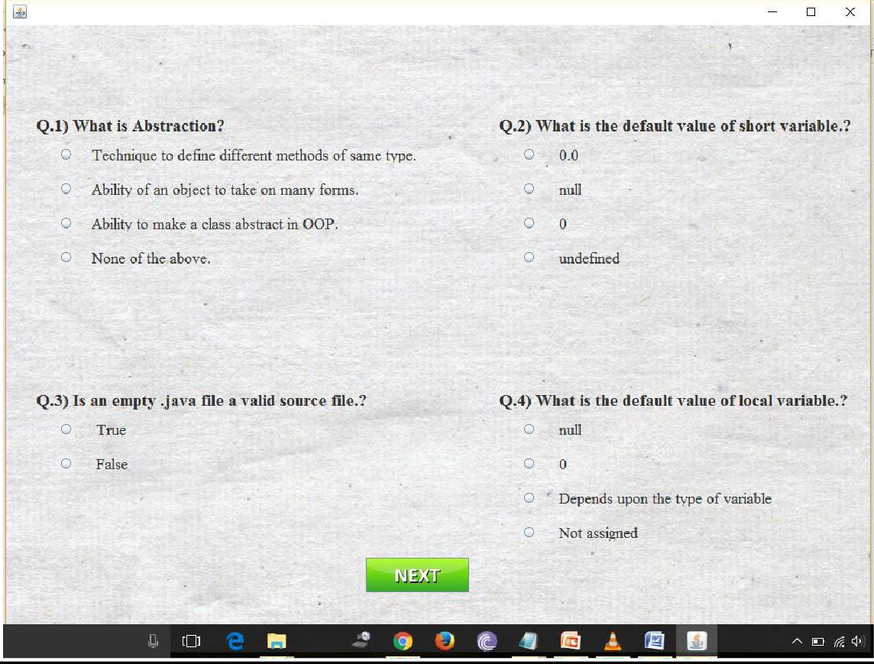

## MCQ’S ON FIRST TOPIC :-

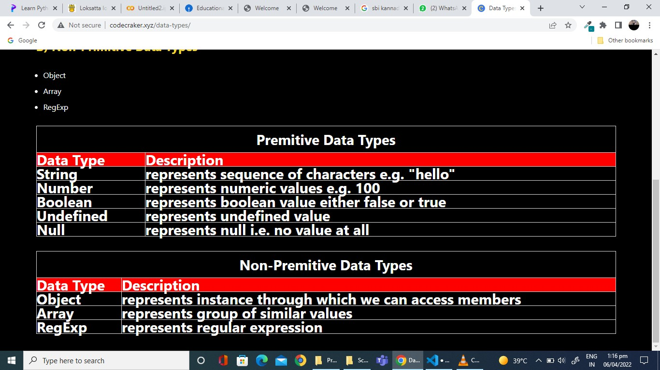

1. **MCQ’S ON SECOND TOPIC :-**

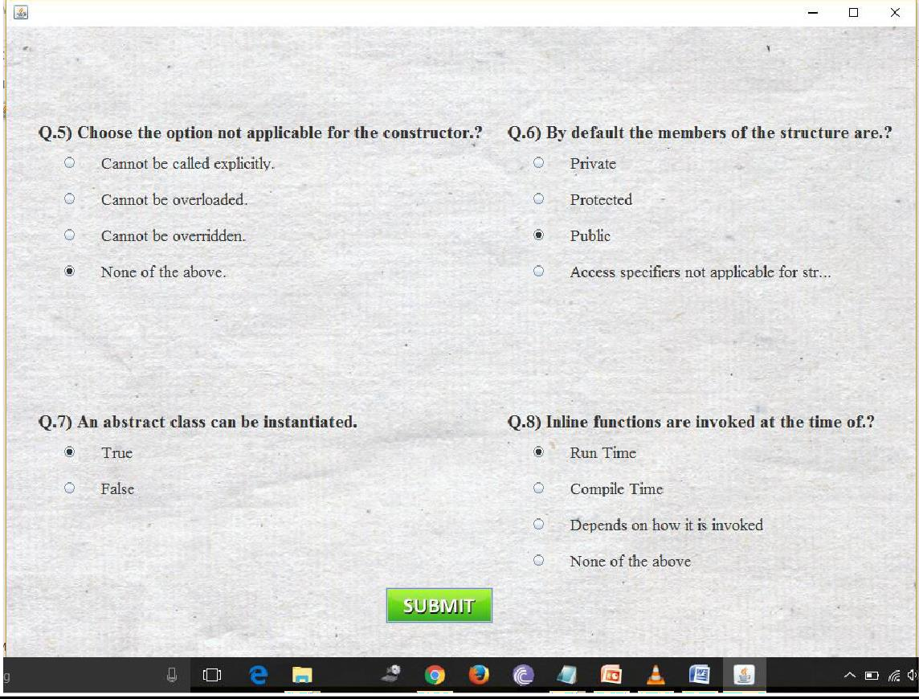

# RESULT GENERATION :-



## CONCLUSION

The project “ **Codecrackers.com**” aims to simplify the process of testing or evaluating the student’s performance by computerizing it and making it user friendly.

This project makes the whole process automated as user just need to enter few details in this to get started and then he can choose the subject of his choice on which he want to take quiz so as to evaluate and enhance his performance. Result is generated automatically in the end enabling student to improve his performance.

This project cover very much every function needed by user in supermarket management system.

CRAKERSCODE.COM

# BIBLIOGRAPHY

1. The complete reference, Java 2, 5th edition by Herbert Schildt.
2. [www.javatpoint.com/java](http://www.javatpoint.com/java)
3. [www.google.co.in](http://www.google.co.in/)
4. Oracle : A Beginner’s Guide by Michael Abbey and Michael J. Korey.